<?xml version="1.0" encoding="utf-8"?>  
<LinearLayout xmlns:android="http://schemas.android.com/apk/res/android"  
    android:layout_width="match_parent"  
    android:layout_height="match_parent"  
    android:paddingLeft="16dp"  
    android:paddingRight="16dp"  
    android:orientation="vertical" >  
    <EditText  
        android:layout_width="match_parent"  
        android:layout_height="wrap_content"  
        android:hint="@string/to" />  
    <EditText  
        android:layout_width="match_parent"  
        android:layout_height="wrap_content"  
        android:hint="@string/subject" />16DP160dp  
    <EditText  
        android:layout_width="match_parent"  
        android:layout_height="0dp"  
        android:layout_weight="1"  
        android:gravity="top"  
        android:hint="@string/message" />  
    <Button  
        android:layout_width="100dp"  
        android:layout_height="wrap_content"  
        android:layout_gravity="right"  
        android:text="@string/send" />  
</LinearLayout>

Step 1 − Create a new project in Android Studio,go to File ⇒ New Project and fill all required details to create a new project.

Step 2

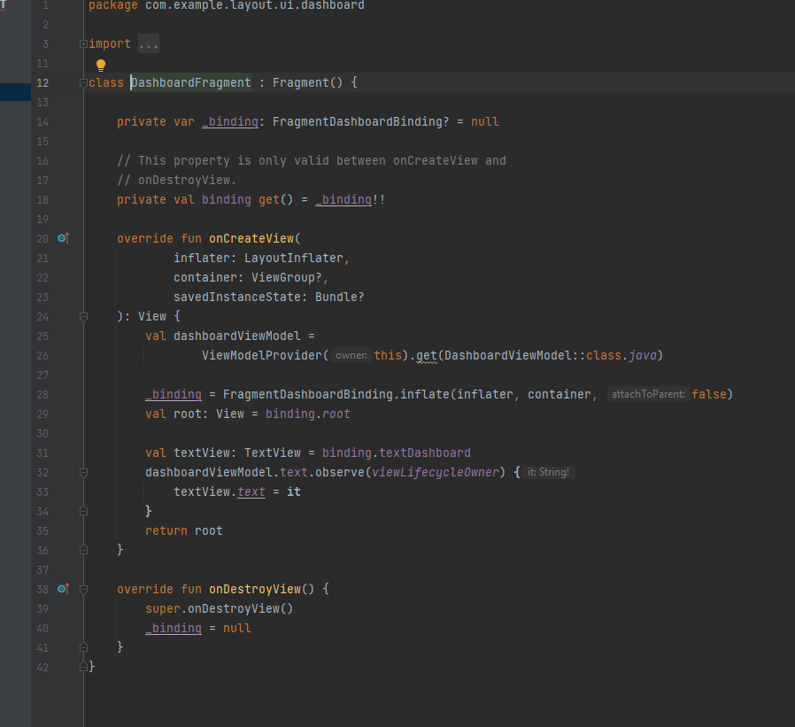Step 3 − Create a new layout in res/layout/ folder and add the following code to res/layout/activity_main.xml. (Second Activity layout )

Step 4 − Add the following code to src/MainActivity.java (First activity)

Step 4 − Create a new activity and add the following code to src/SecondActivity.java (Second Activity)

Step5 − Add the following code to AndroidManifest.xml.

Let's try to run your application. I assume you have connected your actual Android Mobile device with your computer. To run the app from android studio, open one of your project's activity files and click Run Play Iconicon from the toolbar. Select your mobile device as an option and then check your mobile device which will display your default screen.

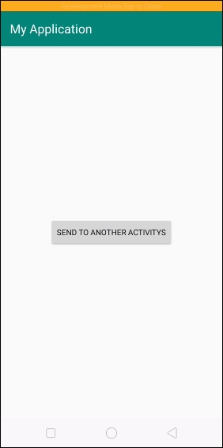

Now click on Button to start new activity as shown below

